## Human-Computer Interaction 2025

Phase 3 Report Template – High Fidelity Prototype Design & Evaluation

# Report Structure

The report MUST include the following sections:

* Title.
* Team member names
* Role & responsibilities of each team member
* **Abstract**
* **Tool:** Describe the tool you used for the high-fidelity design and the rationale behind the choice.
* **Evolution**: Evolution of low fidelity prototype to high fidelity. What changed?
* **High Fidelity Prototype Design:** The high-fidelity porotypes and explanation of each features (icon, button etc), functionalities,

## Usability Study/Evaluation

* + Participants: Target 10 participants. Rationale of the choice of participants.

Demo/bio of the participants

* + 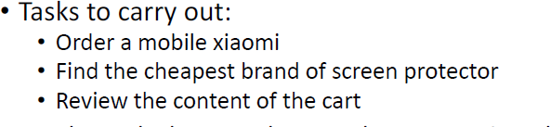Tasks: Create different tasks for the participants to carry out. An example of tasks for a shopping application is below.
  + Document observations about each task. See table below for insight

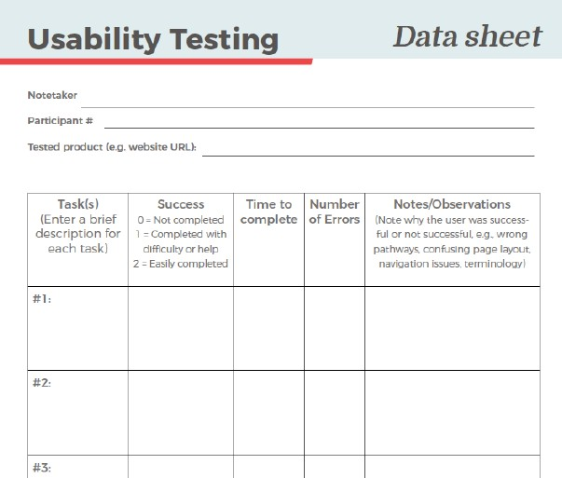

* + Techniques: As users carry out tasks, use three techniques – walk through, think out and observation to gather your data
  + Evaluation:
    1. Qualitative: After users have finished with the tasks, ask various questions centered on glance testing, task-specific etc
    2. 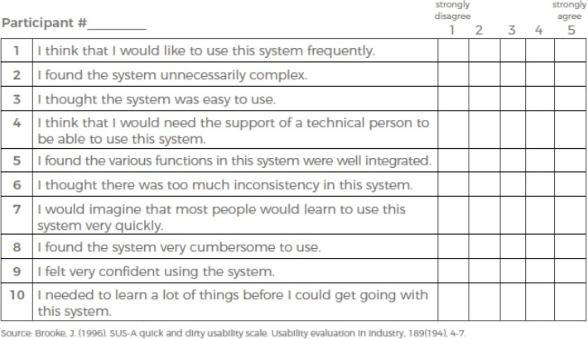Quantitative: Use Brooke J’s Usability scale. See the image below.
  + Analysis: Use appropriate statistical analysis techniques to evaluate quantitative and qualitative data gathered.

## Result Discussion

* + Discuss your results. The implication and make necessary inferences.

## Reflection

* + From inception (understanding the problem) to High Fidelity Prototype
  + Gains: What did you learn from the process of iterative design? How did the process shape your final design? How have your tasks changed as a result of your usability tests? Do you think you could have used more, or fewer, iterations upon your design?
* **Conclusion**

# Group Participation

* Each group should report the participation ratios of its members in the design and data analysis as well as in writing the report.

# Submission Requirements

* Each group will submit ONE report.
* Link for submission would be shared later on.
* Submission deadline is 8th march, 2025